**LAB CYCLE:1 DATE:22/03/2023**

**EXPERIMENT NO:1**

**Aim**: Familiarization of Computer Hardware.

**MAJOR COMPONENTS OF COMPUTER HARDWARE**

Components of a computer system are the primary elements which make the functioning of an electronic device smooth and faster. Computer systems consist of three components as shown in below image: **Central Processing Unit, Input devices and Output devices**. Input devices provide data input to processor, which processes data and generates useful information that’s displayed to the user through output devices. This is stored in computer’s memory.

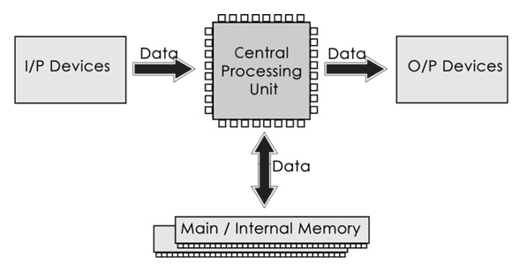

The operations of computer components are given below:

**1) Inputting:** It is the process of entering raw data, instructions and information into the computer. It is performed with the help of input devices.

**2) Storing:** The computer has primary memory and secondary storage to store data and instructions. It stores the data before sending it to CPU for processing and also stores the processed data before displaying it as output.

**3) Processing:** It is the process of converting the raw data into useful information. This process is performed by the CPU of the computer. It takes the raw data from storage, processes it and then sends back the processed data to storage.

**4) Outputting:** It is the process of presenting the processed data through output devices like monitor, printer and speakers.

**5) Controlling:** This operation is performed by the control unit that is part of CPU. The control unit ensures that all basic operations are executed in a right manner and sequence.

Some of the popular input devices are:

1. [Keyboard](https://www.javatpoint.com/input-devices#Keyboard)
2. [Mouse](https://www.javatpoint.com/input-devices#Mouse)
3. [Scanner](https://www.javatpoint.com/input-devices#Scanner)
4. [Joystick](https://www.javatpoint.com/input-devices#Joystick)
5. [Light Pen](https://www.javatpoint.com/input-devices#LightPen)
6. [Touch Pad](https://www.javatpoint.com/input-devices#TouchPad)
7. [Remote](https://www.javatpoint.com/input-devices#Remote)
8. [Touch screen](https://www.javatpoint.com/input-devices#TouchScreen)
9. [VR](https://www.javatpoint.com/input-devices#VR)
10. [Webcam](https://www.javatpoint.com/input-devices#Webcam)
11. [Biometric Devices](https://www.javatpoint.com/input-devices#BiometricDevices)

**Output Devices**

The output device displays the result of the processing of raw data that is entered in the computer through an input device. There are a number of output devices that display output in different ways such as text, images, hard copies, and audio or video.

Some of the popular output devices are:

1. **Monitor**
   * CRT Monitor
   * LCD Monitor
   * LED Monitor
   * Plasma Monitor
2. **Printer**
3. **Projector**

**Central Processing Unit (CPU)**

A Central Processing Unit is also called a processor, central processor, or microprocessor. It carries out all the important functions of a computer. It receives instructions from both the hardware and active software and produces output accordingly. It stores all important programs like operating systems and application software. CPU also helps Input and output devices to communicate with each other. Owing to these features of CPU, it is often referred to as the brain of the computer.

CPU has three components:

* ALU (Arithmetic Logic Unit)
* Control Unit
* Memory or Storage Unit

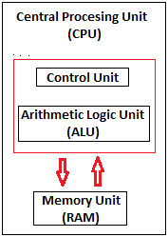

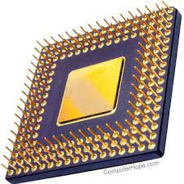

**COMPUTER HARDWARE**

Hardware, which is abbreviated as HW, refers to all physical components of a computer system, including the devices connected to it. You cannot create a computer or use software without using hardware. The screen on which you are reading this information is also a hardware. Some of the commonly used hardware in your computer are described below:

1. Motherboard
2. Monitor
3. Keyboard
4. Mouse

**Motherboard:**

The motherboard is generally a thin circuit board that holds together almost all parts of a computer except input and output devices. All crucial hardware like CPU, memory, hard drive, and ports for input and output devices are located on the motherboard. It is the biggest circuit board in a computer chassis. It allocates power to all hardware located on it and enables them to communicate with each other. It is meant to hold the computer's microprocessor chip and let other components connect to it. Each component that runs the computer or improves its performance is a part of the motherboard or connected to it through a slot or port.

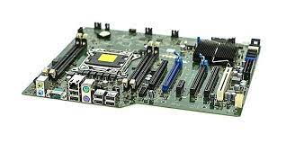 **COMPONENTS OF MOTHERBOARD**

**CPU Slot:** It is provided to install the CPU. It is a link between a microprocessor and a motherboard. It facilitates the use of CPU and prevents the damage when it is installed or removed. Furthermore, it is provided with a lock to prevent CPU movement and a heat sink to dissipate the extra heat.

**RAM Slot:** It is a memory slot or socket provided in the motherboard to insert or install the RAM (Random Access Memory). There can be two or more memory slots in a computer.

**Expansion Slot:** It is also called the bus slot or expansion port. It is a connection or port on the motherboard, which provides an installation point to connect a hardware expansion card, for example, you can purchase a video expansion card and install it into the expansion slot and then can install a new video card in the computer. Some of the common expansion slots in a computer are AGP, AMR, CNR, PCI, etc.

**Capacitor:** It is made of two conductive plates, and a thin insulator sandwiched between them. These parts are wrapped in a plastic container.

**Inductor (Coil):** It is an electromagnetic coil made of a conducting wire wrapped around an iron core. It acts as an inductor or electromagnet to store magnetic energy.

**Northbridge:** It is an integrated circuit that allows communications between the CPU interface, AGP, and memory. Furthermore, it also allows the southbridge chip to communicate with the RAM, CPU, and graphics controller.

**USB Port:** It allows you to connect hardware devices like mouse, keyboard to your computer.

**PCI Slot:** It stands for Peripheral Component Interconnect slot. It allows you to connect the PCI devices like modems, network hardware, sound, and video cards.

**AGP Slot:** It stands for Accelerated Graphics Port. It provides the slot to connect graphics cards.

**Heat Sink:** It absorbs and disperses the heat generated in the computer processor.

**Power Connector:** It is designed to supply power to the motherboard.

**CMOS battery:** It stands for complementary metal-oxide-semiconductor. It is a memory that stores the BIOS settings such as time, date, and hardware settings.